**PRACTICUM PROBLEMS**

2.1 Problem 1

Load the Movielens 100k dataset (ml-100k.zip) into Python using Pandas dataframes. Build a user profile on unscaled data for both users 200 and 15, and calculate the cosine similarity and distance between the user's preferences and the item/movie 95. Which user would a recommender system suggest this movie to?

**Answer:**

The recommender system will suggest movie 95 (Aladin) to user 200 based on the values of cosine distance obtained which are 0.405 and 0266 for users 200 and 15 respectively.

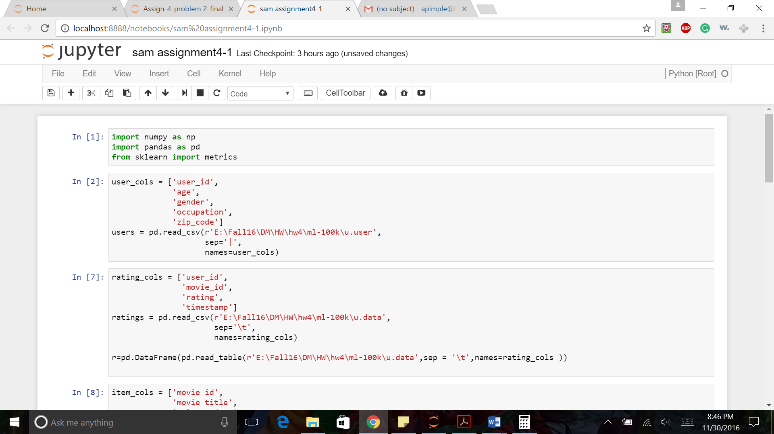

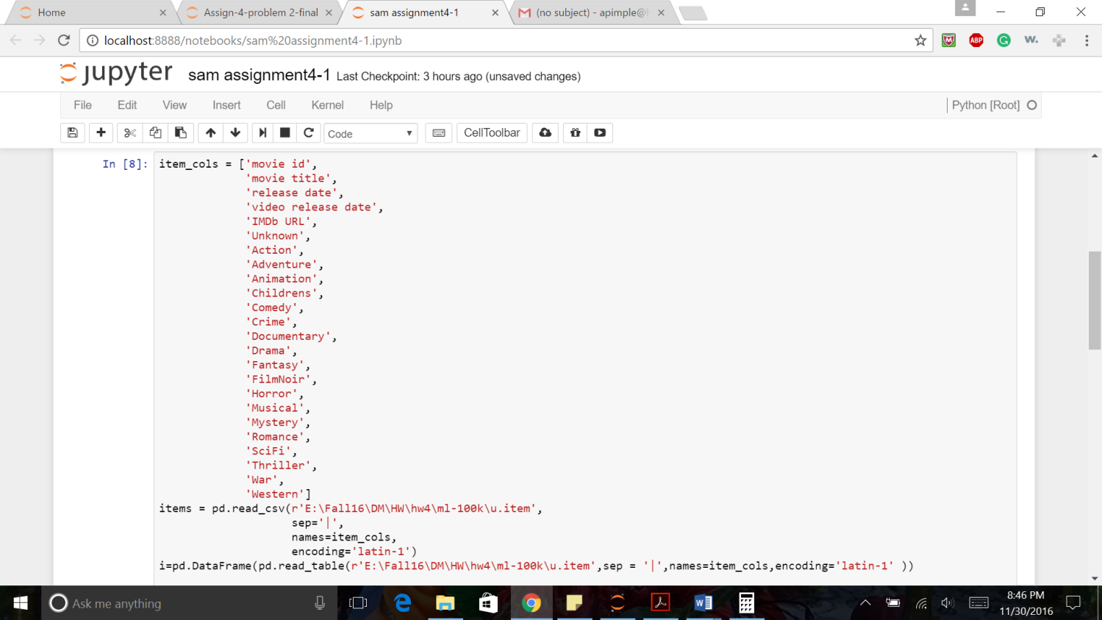

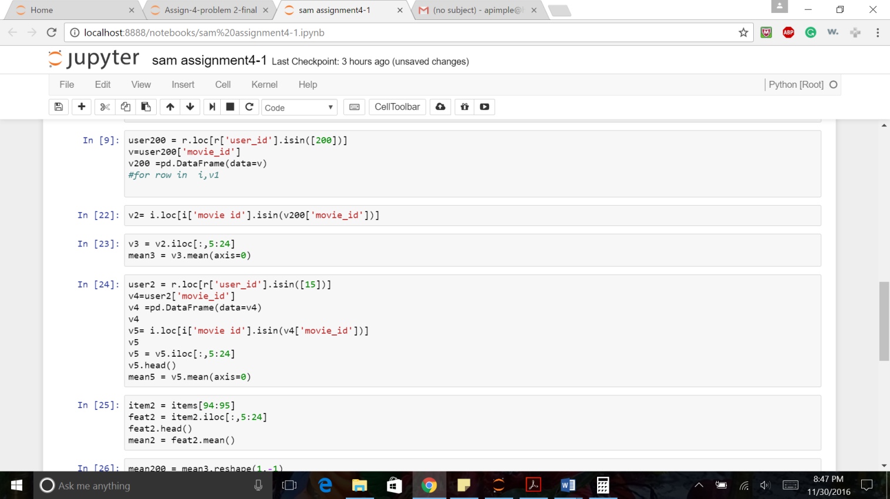

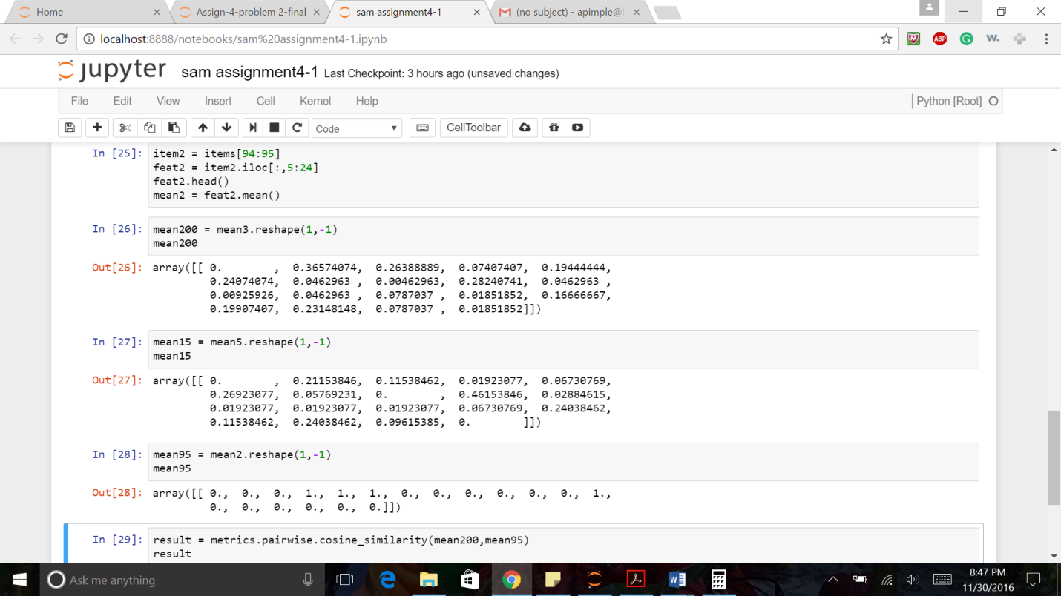

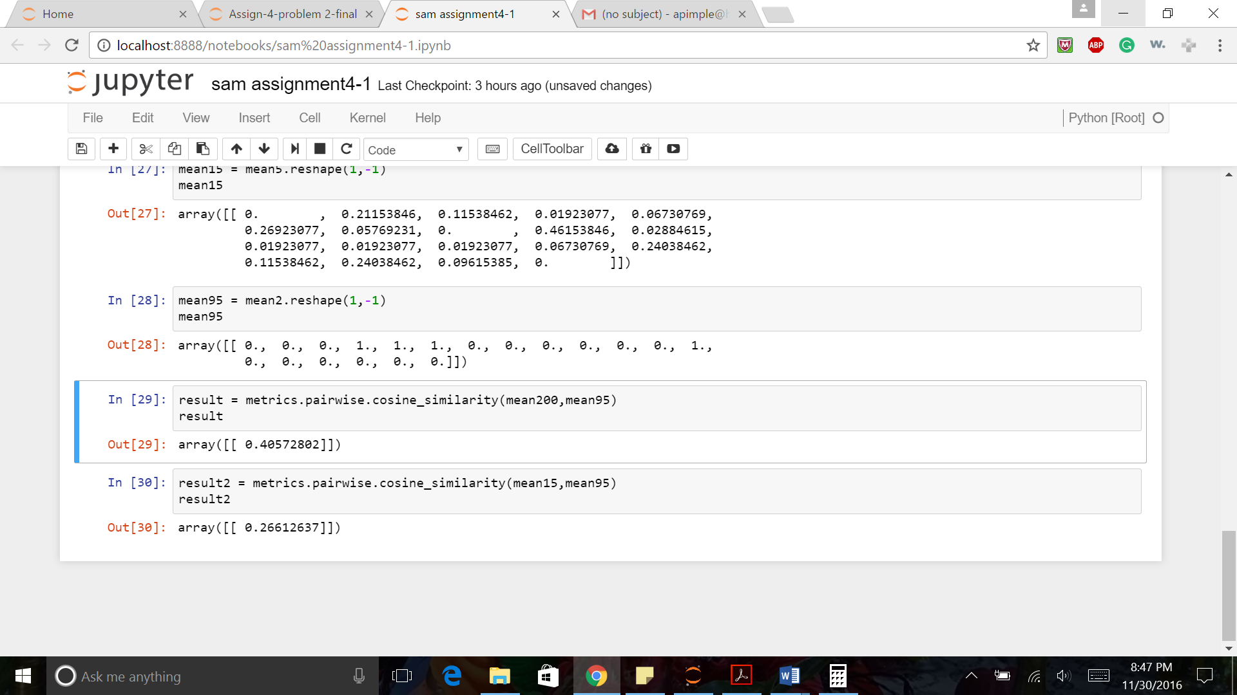

2.2 Problem 2

Load the Movielens 100k dataset (ml-100k.zip) into Python using Pandas dataframes. Convert the ratings data into a utility matrix representation, and find the 10 most similar users for user 1 based on cosine similarity of the user ratings data. Based on the average of of the ratings for item 508 from the similar users, what is the expected rating for this item for user 1?

**Answer:**

The expected rating for item 508 by user 1 will be 0.2689 ~ 0.27

